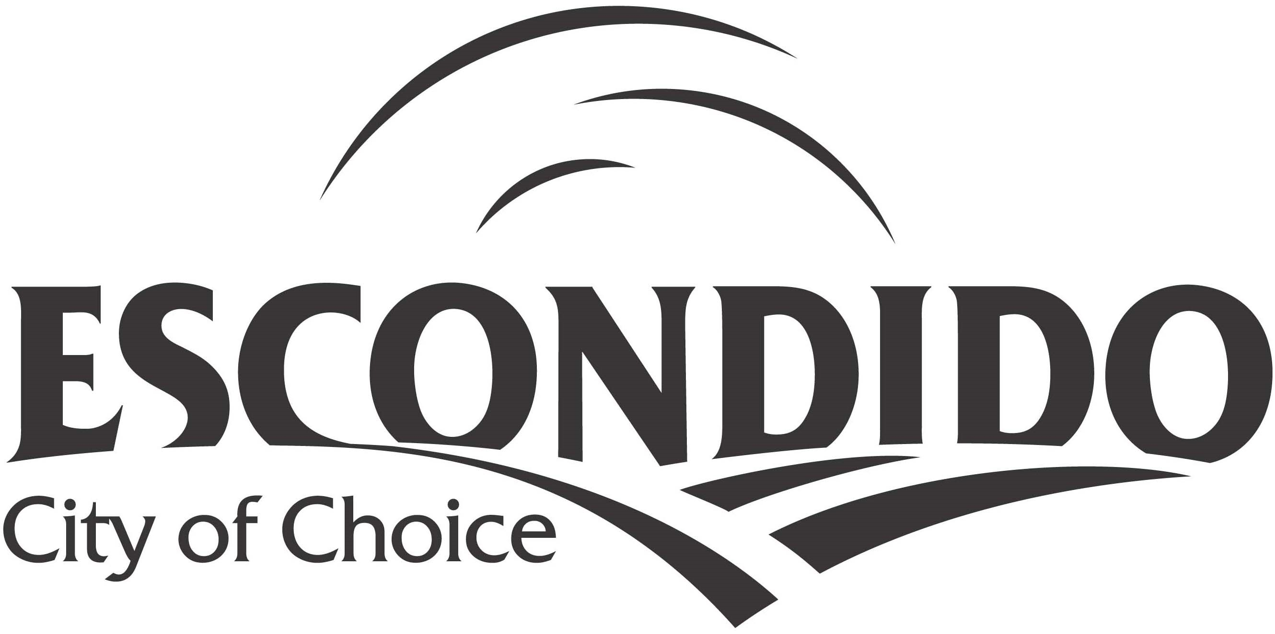

Executive Summary

First Amendment: The City of Escondido is requesting to make a substantial amendment to the 2022 Annual Action Plan to add a new goal of public safety. The City needs to replace two fire trucks in low-mod service areas and would like to use unallocated funds from program years 2020, 2021, 2022 to pay for the deposit (not to exceed $700,000). All changes to this documents have been made in track changes and can be found on pages 3, 30 and 31.

AP-05 Executive Summary - 24 CFR 91.200(c), 91.220(b)
1. Introduction
As a recipient of federal funds from the U.S. Department of Housing and Urban Development (HUD), the City of Escondido is required to prepare and submit a Consolidated Plan every five years. The City’s current Consolidated Plan was approved in 2020. It covers the five-year period from 2020 through 2024 and applies to the following three federal grant programs:
Community Development Block Grant (CDBG)
The primary objective of the CDBG program is the development of urban communities through the provision of improved living environments, expansion of economic opportunity, and providing suitable housing. Funds are intended to serve low- and moderate-income residents and areas.
HOME Investment Partnerships Program (HOME)
The HOME program increases the availability, quality, and access to affordable and decent housing for low-income residents.
Emergency Solutions Grant (ESG)
The purpose of the ESG program is to help individuals and families who are at-risk or experiencing homelessness through prevention, street outreach, emergency and rapid rehousing resources.
The Consolidated Plan is a document developed through a collaborative process where Escondido stakeholders identify community improvements, needs and priorities to address using federal grant funds and other available resources. To ensure maximum community participation, the City created a Citizen Participation Plan which outlines how the City solicits and incorporates the views of community members, organizations and other interested parties into the decision-making process. Through the use of surveys, community meetings and public hearings, the residents of Escondido have a multitude of opportunities to shape the priorities and strategies of the Consolidated Plan.
The Annual Action Plan for Fiscal Year (FY) 2022-23 (the third year of the Consolidated Planning period) includes activities the City will undertake to address its priority needs and objectives as outlined in the 2020-2024 Five Year Consolidated Plan. These activities will be undertaken with federal FY 2022-23 CDBG and HOME program funds. The FY 2022-23 was announced by HUD on May 13, 2022. The City received its official allocation letter from HUD on June 9, 2022 stating it would receive a total allocation of $2,254,596 ($1,548,067 in CDBG funds, $706,529 in HOME funds and $0 in ESG) which is a 9.7% decrease from the funding allocations received in FY 2021-22. Each program has its own unique guidelines and requirements.
2. Summarize the objectives and outcomes identified in the Plan
This could be a restatement of items or a table listed elsewhere in the plan or a reference to another location. It may also contain any essential items from the housing and homeless needs assessment, the housing market analysis or the strategic plan.
The City has extensive housing and community development needs and CDBG, HOME and ESG funds are not sufficient to address all the needs of the City. The City will use CDBG, HOME and ESG funds, in conjunction with other funding as it becomes available to meet the objectives of all programs. The priority needs and associated goals identified in the Consolidated Plan are shown below:
CDBG Priority: Homeless Services
Goal: Supporting homeless shelter and other services
CDBG Priority: Neighborhood revitalization
Goal: Improve the livability of neighborhoods
CDBG Priority: Basic Needs
Goal: Provide access to food, water, shelter and sanitation
CDBG Priority: Health and Human Development
Goal: Provide access to recreation, education and healthcare (including mental health)
CDBG Priority: Economic Development
Goal: Provide economic development opportunities to low-mod income residents and businesses
CDBG Priority: Public Safety
Goal: Increase safety and updating equipment serving in low- and-moderate income communities
HOME Priority: Creation and preservation of affordable rental housing
HOME Priority: Conservation and expansion of affordable homeownership opportunities
ESG Priority: Homelessness Prevention
Goal: To keep households at imminent risk of homelessness from becoming homeless
ESG Priority: Emergency Shelters
Goal: To temporarily house homeless residents
ESG Priority: Essential services to shelter residents
Goal: To provide basic needs and case management to homeless residents living in an emergency shelter
ESG Priority: Engagement of homeless individuals and families
Goal: To conduct outreach to unsheltered people
ESG priority: Rapid Rehousing
Goal: To provide permanent housing to homeless households
3. Evaluation of past performance
This is an evaluation of past performance that helped lead the grantee to choose its goals or projects.
During the 2021-22 program year, the City utilized its CDBG, HOME and ESG funds for a variety of different housing and community development activities. Twenty-one activities were funded through CDBG, two programs through HOME, and one through ESG.
The following includes some of the accomplishments of the prior year, which helped determine the current goals and projects:
Housing: The City has not received or processed any formal homebuyer applications for FY 2021-22.
The City used $1,000,000 in HOME Funds to assist Habitat for Humanity in the construction of 10 new affordable housing for-sale units for low-income households. The property is located at 245 E. El Norte Parkway, Escondido, CA and construction began in May 2022. These units are expected to be finalized in April 30, 2024 and sold by December 2024.
Community/Neighborhood Development: During the prior Action Plan year, the City carried out many programs and projects that furthered the City’s priority to revitalize neighborhoods. During this time period, the City held two Neighborhood Leadership Forum meetings, the first meetings since the onset of COVID in 2019. The City also conducted six neighborhood cleanups and three NEAT sweeps.
A dozen public service activities were completed during the prior Action Plan year in support of low- and moderate-income Escondido residents. Meals on Wheels and Mama’s Kitchen provided in-home delivery to Escondido seniors and those home-bound due to critical illness. CDBG dollars were used to support the transportation of seniors to the Park Avenue Community Center where congregate meals were provided and resource navigation is made available. Special lock boxes were also installed using CDBG funds to allow emergency personnel quick access to disabled residents’ homes without the need for damaging property during an emergency response.
Public Facility Improvements: During this current year, many capital improvement projects have progressed using CDBG funds. Community outreach was performed to solicit feedback regarding the Escondido Creek Trail Fencing along both sides of the Trail between N. Ash and N. Rose. A Request for Proposal (RFP) has been developed and is to be released and construction is expected to begin during the 2022-2023 program year. An RFP has also been prepared to complete street light improvements in the Old Escondido Neighborhood that is also anticipated to begin construction in the upcoming year.
A public improvement was also completed this year at Urban Corps of San Diego County’s facility at 2200 Micro Place. The CDBG funds used for this improvement will see 50 participants, called Corpsmembers, benefit as low-income disconnected and disadvantaged young adults by giving them a second chance for education and provides needed supports to gain employment. This program that promotes education and employment of local young people reaches their children, families, and their neighborhoods and broader communities.
New safety lights were installed throughout the Jesmond Dene Park parking lot with CDBG funds to promote safe and increased utilization of the park.
Homelessness:
The City funded Escondido Education COMPACT to provide homeless prevention services to families at-risk of experiencing homelessness in Escondido. The agency provided financial literacy classes, case management, and rental and utility assistance for 100 families. As of May 2022, the program served 48 households with rental assistance and case management for homelessness prevention. COMPACT provided financial literacy and budgeting workshops to low-income households identified as at-risk of experiencing homelessness at the affordable housing complexes. Most of the program referrals were from the Escondido Union School District or word of mouth from other participants.
4. Summary of Citizen Participation Process and consultation process
Summary from citizen participation section of plan.
The City of Escondido follows the Citizen Participation Plan included as part of the 2020-2024 Consolidated Plan. In response to the COVID-19 pandemic, the City amended its Participation Plan in May 2020 in order to promote and support social distancing while continuing to offer the public an opportunity to provide valuable insight and input on federal funds.
The City published a notification in the Escondido Times- Advocate on May 12, 2022 informing the public of the upcoming City’s Public Hearing on June 15, 2022 and eliciting feedback on the Annual Action Plan from May 12 – June 10, 2022.
The draft Action Plan was posted on the City’s website, which included an electronic comment box, and paper copies were made available at Escondido City Hall at 201 N. Broadway, Escondido, CA 92025 and the Escondido Public Library at 239 S. Kalmia Street, Escondido, CA 92025. The City received nine public comments in support of the COMPACT’s Success Center, COMPACT’s ESG-funded homelessness prevention services, and senior services. City staff incorporated the feedback into the staff report and presentation to the City Council on June 15, 2022.
5. Summary of public comments
This could be a brief narrative summary or reference an attached document from the Citizen Participation section of the Con Plan.
During the public comment period, 9 public comments were submitted in support of Escondido Education COMPACT’s proposed Success Center, homelessness prevention services through COMPACT, and senior services.
6. Summary of comments or views not accepted and the reasons for not accepting them
None
7. Summary

PR-05 Lead & Responsible Agencies – 91.200(b)
1. Agency/entity responsible for preparing/administering the Consolidated Plan
Describe the agency/entity responsible for preparing the Consolidated Plan and those responsible for administration of each grant program and funding source.
Agency Role | Name | Department/Agency
Lead Agency | Escondido

CDBG Administrator | Escondido | Housing and Neighborhood Services Division
HOPWA Administrator
HOME Administrator | Escondido | Housing and Neighborhood Services Division
ESG Administrator |  | Housing and Neighborhood Services Division
HOPWA-C Administrator
Table 1 – Responsible Agencies

Narrative (optional)
The City of Escondido’s Housing and Neighborhood Services Division is responsible for administering the CDBG and HOME programs. Division staff is also responsible for preparing the Annual Action Plan, Consolidated Plan, data and financial reports. Many programs and services operate for one year, but some capital improvement projects can take multiple years to complete due to complexity, cost and staff time.
Consolidated Plan Public Contact Information
For questions regarding the City of Escondido’s CDBG, HOME or ESG programs please contact Holly Nelson, Housing and Neighborhood Services Program Manager, at (760) 839-4518 or HNelson@escondido.org; or Jonathan Lung at JLung@escondido.org or (760) 839-4579 or JLung@escondido.org. Program staff is located at Escondido City Hall at 201 North Broadway, Escondido, CA 92025.

AP-10 Consultation – 91.100, 91.200(b), 91.215(l)
1. Introduction
As part of the Consolidated Plan and Action Plan development process, the City encourages maximum citizen participation. The City of Escondido staff presented at six community meetings during March and June 2022 to discuss the CBDG, ESG and HOME programs. City staff encouraged community feedback on the Annual Action Plan. Four of the six meetings were in held in-person and two virtually. Staff was able to provide outreach to nearly 225 individuals who were comprised of service providers, educators, residents, and business owners in Escondido.
Provide a concise summary of the jurisdiction’s activities to enhance coordination between public and assisted housing providers and private and governmental health, mental health and service agencies (91.215(l))
The City of Escondido is committed to fostering relationships with local community groups to address homelessness, senior and youth services, mental and physical health, and basic needs. The City maintains an updated agency list of all interested groups in development of this Action Plan.
Community Meetings
Describe coordination with the Continuum of Care and efforts to address the needs of homeless persons (particularly chronically homeless individuals and families, families with children, veterans, and unaccompanied youth) and persons at risk of homelessness.
The Regional Task Force on Homelessness (RTFH) is the lead agency and administrative entity for the Continuum of Care for the San Diego County. RTFH operates the Homeless Management Information System (HMIS) that captures data on individuals and households who are at-risk or experiencing homelessness in San Diego County as well as provides system-level regarding information on homeless services utilization, performance, and outcomes. City of Escondido staff regularly consults and coordinates with RTFH for data, best practices, local, state and federal funding opportunities, technical assistance, and system improvement.
Describe consultation with the Continuum(s) of Care that serves the jurisdiction's area in determining how to allocate ESG funds, develop performance standards for and evaluate outcomes of projects and activities assisted by ESG funds, and develop funding, policies and procedures for the operation and administration of HMIS
The City of Escondido collaborates with RTFH to determine current needs and priorities for assisting the County’s homeless population, best practice standards related to homeless prevention, outreach, emergency shelter, rapid rehousing, HMIS, permanent housing and spending ESG funds.
2. Describe Agencies, groups, organizations and others who participated in the process and describe the jurisdiction’s consultations with housing, social service agencies and other entities

Table 2 – Agencies, groups, organizations who participated
1 | Agency/Group/Organization | COUNTY OF SAN DIEGO
 | Agency/Group/Organization Type | Housing  Agency - Emergency Management  Other government - County  Fire Department
 | What section of the Plan was addressed by Consultation? | Hazard Mitigation
 | Briefly describe how the Agency/Group/Organization was consulted. What are the anticipated outcomes of the consultation or areas for improved coordination? | The County of San Diego Emergency Services Department, in conjunction with the City of Escondido Fire Department, developed a countywide disaster plan. The plan includes the top potential hazards in each area of the county. The City consults this plan when determining how to allocate capital funds, including ensuring that impacts to lower income households are lessened.
2 | Agency/Group/Organization | Escondido School District
 | Agency/Group/Organization Type | Services - Broadband Internet Service Providers  Services - Narrowing the Digital Divide  Business and Civic Leaders
 | What section of the Plan was addressed by Consultation? | Broadband Services
 | Briefly describe how the Agency/Group/Organization was consulted. What are the anticipated outcomes of the consultation or areas for improved coordination? | At the beginning of the pandemic, government, grant and private funding was made available to the school districts in Escondido to ensure that broadband was widely available to Escondido students participating in remote learning. Additional participation by the City was not needed as broadband provision was a focus of efforts. Continued focus, possibly including the City, will be on increasing broadband availability in the city in the upcoming years, based on information that was gained during the pandemic.

Identify any Agency Types not consulted and provide rationale for not consulting
As part of the development process for the Annual Action Plan and Consolidated Plan, the City encourages maximum citizen and stakeholder participation from all areas and organizations. The City used a variety of outreach methods and no agency or groups were excluded during the process.

Other local/regional/state/federal planning efforts considered when preparing the Plan
Name of Plan | Lead Organization | How do the goals of your Strategic Plan overlap with the goals of each plan?
Continuum of Care | RTFG | The City is funding temporary emergency shelter and releasing an RFP to build permanent housing at 30% AMI using CDBG and HOME dollars.
Table 3 – Other local / regional / federal planning efforts

Narrative (optional)

AP-12 Participation – 91.105, 91.200(c)
1. Summary of citizen participation process/Efforts made to broaden citizen participation
Summarize citizen participation process and how it impacted goal-setting

Citizen Participation Outreach
Sort Order | Mode of Outreach | Target of Outreach | Summary of  response/attendance | Summary of  comments received | Summary of comments not accepted and reasons | URL (If applicable)
1 | Newspaper Ad | Non-English Speaking - Specify other language: Spanish  Non-targeted/broad community | A notice was published in the Escondido Times-Advocate newspaper announcing the January 26, 2022 public hearing. | None received | None
2 | Public Meeting | Non-targeted/broad community | The City Council hearing to reaffirm local priorities was held virtually on January 26, 2022. | None received | None
3 | Newspaper Ad | Non-targeted/broad community | A newspaper notice was posted on May 12, 2022 to advertise the public hearing on June 15, 2022. The notice encouraged community input on the draft plan and said it would be available for next 30-days for review (5/12/22-6/10/22). | Nine total comments received in support of a local public improvement, homeless services, and senior center services. | None
4 | Public Meeting | Non-targeted/broad community | A Public Hearing was held on June 15, 2022 to recommend approval of funding recommendations. | Various community members and recommended CDBG subrecipients provided public comment in support of the Annual Action Plan and responded to City Council questions. | None
Table 4 – Citizen Participation Outreach

Expected Resources

AP-15 Expected Resources – 91.220(c)(1,2)
Introduction
The City of Escondido is a HOME participating jurisdiction and a CDBG entitlement jurisdiction. $1,548,067 in CDBG funds and $706,529 in HOME funds were allocated for a total of $2,254,596 in HUD grant funds during the fiscal year. Accordingly, the City anticipates receiving an additional approximately $3,433,000 in CDBG funds, $1,250,000 in HOME funds, and $300,000 in ESG funds over the next two years. Escondido does not receive funding under the Housing Opportunities for Persons with AIDS (HOPWA) program. Program income received from the repayment of CDBG-owned rental property will be reassigned for permitted activities. Any additional Program Income funds also will be reprogrammed into allowable programs or projects, as identified during the Action Plan process.
Anticipated Resources
Program | Source of Funds | Uses of Funds | Expected Amount Available Year 1 |  |  |  | Expected Amount Available Remainder of ConPlan  $ | Narrative Description
 |  |  | Annual Allocation: $ | Program Income: $ | Prior Year Resources: $ | Total:  $
CDBG | public - federal | Acquisition  Admin and Planning  Economic Development  Housing  Public Improvements  Public Services | 1,548,067 | 0 | 0 | 1,548,067 | 3,096,134 | Funding based on anticipated HUD allocation.
HOME | public - federal | Acquisition  Homebuyer assistance  Homeowner rehab  Multifamily rental new construction  Multifamily rental rehab  New construction for ownership  TBRA | 706,529 | 0 | 0 | 706,529 | 1,413,058 | Funding based on anticipated HUD allocation.
ESG | public - federal | Conversion and rehab for transitional housing  Financial Assistance  Overnight shelter  Rapid re-housing (rental assistance)  Rental Assistance  Services  Transitional housing | 0 | 0 | 0 | 0 | 0
Table 1 - Expected Resources – Priority Table

Explain how federal funds will leverage those additional resources (private, state and local funds), including a description of how matching requirements will be satisfied

If appropriate, describe publically owned land or property located within the jurisdiction that may be used to address the needs identified in the plan
The City will be evaluating its publicly-owned land and property for the homeless day center and future affordable housing opportunities.
Discussion

Annual Goals and Objectives

AP-20 Annual Goals and Objectives
Goals Summary Information
Sort Order | Goal Name | Start Year | End Year | Category | Geographic Area | Needs Addressed | Funding | Goal Outcome Indicator
1 | Create and preserve affordable rental housing | 2020 | 2024 | Affordable Housing | City of Escondido | Creation/preservation of affordable rental housing  Homelessness prevention | HOME: $585,876 | Rental units constructed: 40 Household Housing Unit
2 | Affordable ownership opportunities | 2020 | 2024 | Affordable Housing | City of Escondido | Conservation/expansion afford homeowner opport | HOME: $50,000 | Direct Financial Assistance to Homebuyers: 2 Households Assisted
3 | Support homeless shelter and other services | 2020 | 2024 | Homeless | City of Escondido | Homelessness services  Emergency Shelter  Essential services to shelter residents  Engagement of homeless individuals and families | CDBG: $70,000 | Homeless Person Overnight Shelter: 320 Persons Assisted
4 | Prov access to food, water, shelter and sanitation | 2020 | 2024 | Homeless | City of Escondido | Basic needs | CDBG: $122,610 | Public Facility or Infrastructure Activities for Low/Moderate Income Housing Benefit: 2500 Households Assisted  Public service activities for Low/Moderate Income Housing Benefit: 963 Households Assisted
5 | Access to rec, ed and healthcare (inc mentl hlth) | 2020 | 2024 | Non-Housing Community Development | City of Escondido | Health and human development | CDBG: $416,543 | Public Facility or Infrastructure Activities for Low/Moderate Income Housing Benefit: 700 Households Assisted  Public service activities for Low/Moderate Income Housing Benefit: 240 Households Assisted
6 | Improve the livability of neighborhoods | 2020 | 2024 | Non-Housing Community Development | City of Escondido | Neighborhood Revitalization | CDBG: $415,345 | Public service activities for Low/Moderate Income Housing Benefit: 150 Households Assisted  Housing Code Enforcement/Foreclosed Property Care: 100 Household Housing Unit  Other: 100 Other
7 | Keep HH at risk from becoming homeless | 2020 | 2024 | Non-Homeless Special Needs | City of Escondido | Homelessness prevention
8 | Temporarily house homeless residents | 2020 | 2024 | Homeless | City of Escondido | Emergency Shelter
9 | Basic needs and case mgt to residents in shelter | 2020 | 2024 | Homeless | City of Escondido | Essential services to shelter residents
10 | Engage/assess homeless indiv/families on street | 2020 | 2024 | Homeless | City of Escondido | Engagement of homeless individuals and families | CDBG: $213,956 | Public Facility or Infrastructure Activities other than Low/Moderate Income Housing Benefit: 250 Persons Assisted
11 | Provide perm hsg to homeless households | 2020 | 2024 | Homeless | City of Escondido | Basic needs
Table 2 – Goals Summary

Goal Descriptions

1 | Goal Name | Create and preserve affordable rental housing
 | Goal Description | Assist in the production of new, affordable rental housing through construction and acquisition/rehabilitation of existing rental units. Units would be extremely-low households.
2 | Goal Name | Affordable ownership opportunities
 | Goal Description | The City will provide direct assistance to first-time, low-income homebuyers for down payment or closing cost assistance. The City also will assist in the production of affordable homeownership housing for lower income homebuyers.
3 | Goal Name | Support homeless shelter and other services
 | Goal Description | Provide shelter beds for individuals and households experiencing homelessness.
4 | Goal Name | Prov access to food, water, shelter and sanitation
 | Goal Description | Support basic needs, such as food, water, shelter, sanitation for homeless and low- and moderate-income persons.
5 | Goal Name | Access to rec, ed and healthcare (inc mentl hlth)
 | Goal Description | Support educational, recreational and mental health for all members of the community, including youth, families and seniors.
6 | Goal Name | Improve the livability of neighborhoods
 | Goal Description | Work with neighborhood leaders to build community, reduce slum and blight and beautify low and moderate income neighborhoods.
7 | Goal Name | Keep HH at risk from becoming homeless
 | Goal Description | This need is being addressed by the City's ESG-CV dollars.
8 | Goal Name | Temporarily house homeless residents
 | Goal Description | This need is being addressed using the City's ESG-CV dollars.
9 | Goal Name | Basic needs and case mgt to residents in shelter
 | Goal Description | This need is being addressed using the City's ESG-CV dollars.
10 | Goal Name | Engage/assess homeless indiv/families on street
 | Goal Description | The City has alllocated an additional $213,956 for the purchase/conversion of a homeless navigation/day center. This program will engage, assess and connect individuals and households living on the streets with temporary and permanent housing resources. The City will continue to engage and serve this population through the use of its ESG-CV dollars.
11 | Goal Name | Provide perm hsg to homeless households
 | Goal Description | This need is being addressed by the City's ESG-CV dollars.

Projects

AP-35 Projects – 91.220(d)
Introduction
The City of Escondido Housing and Neighborhood Services Division will serve as the lead agency in the administration of all CDBG and HOME projects proposed in this plan. The City will contract with local nonprofit agencies and organizations to administer fair housing activities and some public services, in addition to administering most programs and projects directly. Any contract agencies (subrecipients) will be responsible for program implementation and all performance will be monitored by the City of Escondido.

Projects
# | Project Name
1 | CDBG Admin
2 | Public Services
3 | Fair Housing
4 | Capital Improvements
5 | Neighborhood Revitalization
6 | HOME Administration
7 | Homebuyer Entry Loan Program
8 | Housing Development
Table 3 - Project Information

Describe the reasons for allocation priorities and any obstacles to addressing underserved needs
Allocation priorities for CDBG and HOME funds were made based on the Housing Needs Assessment, Market Analysis, and the Community Needs Assessment process of the 2020-2024 Consolidated Plan.
The First Time Homebuyer Program remains very popular in the community. Housing and Neighborhood staff receives multiple phone calls a week regarding the program. Although the public interest is there, the City has faced challenges, which have led to a decline in loan applications and the overall number of issuance of loans as we had previously anticipated. Some of the program’s major challenges continue to be an overall lack of housing inventory. General market forces and strict federal regulations on income levels and maximum purchase price limits continue to hinder the opportunity for potential low-income homebuyers to qualify for our program. Prices for a single-family home have increased significantly over the past years, exceeding HUD’s annual maximum value limit of $589,000. Households may qualify based on income, but due to the high housing market, an average three-bedroom house in Escondido lists for over $500,000. Other contributing factors include the City’s stringent front and back end ratios (elevated housing costs to income ratios). The City’s First Time Homebuyer Program provides down payment and/or closing cost assistance to households earning up to 80% Area Median Income (AMI). The program provides a deferred payment loan for the lessor of 5% of the purchase price, up to $25,000.
The City recognizes this program is important for low-to-moderate income households who are trying to pursue homeownership; however, a comprehensive evaluation of the program needs to be conducted to understand how the City can improve the existing homebuyer program following responsible underwriting and lending standards, ensuring low-income homebuyers are able to afford and sustain homeownership long term.

AP-38 Project Summary
Project Summary Information

1 | Project Name | CDBG Admin
 | Target Area | Neighborhood Groups  CDBG Eligible Areas  City of Escondido
 | Goals Supported | Support homeless shelter and other services  Prov access to food, water, shelter and sanitation  Access to rec, ed and healthcare (inc mentl hlth)  Improve the livability of neighborhoods  Keep HH at risk from becoming homeless  Temporarily house homeless residents  Basic needs and case mgt to residents in shelter  Engage/assess homeless indiv/families on street  Provide perm hsg to homeless households
 | Needs Addressed | Creation/preservation of affordable rental housing  Homelessness services  Basic needs  Health and human development  Neighborhood Revitalization  Homelessness prevention  Emergency Shelter  Essential services to shelter residents  Engagement of homeless individuals and families  Rapid rehousing for homeless individuals/families
 | Funding | CDBG: $274,613
 | Description | General administration of the CDBG program. Includes staff costs for compliance, reporting, financial management and program monitoring.
 | Target Date | 6/30/2023
 | Estimate the number and type of families that will benefit from the proposed activities
 | Location Description | Citywide
 | Planned Activities | Staff time, administration, compliance, reporting, financial management and monitoring.
2 | Project Name | Public Services
 | Target Area | City of Escondido
 | Goals Supported | Support homeless shelter and other services  Prov access to food, water, shelter and sanitation  Access to rec, ed and healthcare (inc mentl hlth)  Temporarily house homeless residents  Basic needs and case mgt to residents in shelter
 | Needs Addressed | Homelessness services  Basic needs  Health and human development  Emergency Shelter  Essential services to shelter residents
 | Funding | CDBG: $231,553
 | Description | Public services benefitting low-mod community members, provided by the City or local non-profit agencies and organizations.
 | Target Date | 6/30/2022
 | Estimate the number and type of families that will benefit from the proposed activities | Approximately 1600 low- and moderate-income, disabled, housing-insecure, and various other vulnerable Escondido residents will benefit from the CDBG-funded public service activities.
 | Location Description | Citywide
 | Planned Activities | - Senior Nutrition ($56,110)Provides seniors with nutritionally balanced meals that are designed to sustain and improve health and reduce isolation by promoting socialization.  - Senior Care ($16,000)Improves the quality of life for income seniors living in Escondido by improving accessibility to referral services, decreasing isolation, and assisting them to age in place with confidence and vitality.  - Senior Transportation ($34,610)Reduces isolation of seniors and assisting with overall health and welfare by providing transportation to the Escondido Senior Center for the Senior Nutrition program.  - Meal on Wheels In-Home Meal Delivery ($25,000)Delivers up to two nutritious meals a day to the home, accompanied by a daily safety check, in-home social visit, and care navigation for Escondido seniors.  - Mama’s Kitchen Home Delivered Meal Service ($7,500)Provides medically tailored meals to low- and moderate-income Escondido residents facing critical illness such as cancer, type 2 diabetes, congestive heart failure, and chronic kidney disease.  - Palomar Family Counseling Services Healthy Minds, Thriving Youth ($22,333)Provides mental health therapy to high school-aged youth of low- and moderate-income families to reduce the negative effects that disproportionately affect low-income youth.  - Center for Community Solutions Domestic Violence Shelter ($25,000)Provides emergency domestic violence shelter at Hidden Valley House to prevent homelessness, provide shelter, meet basic needs, and connect domestic violence victims to mental health services.  - Alliance for Regional Solutions Bridge to Housing Shelter Network ($45,000). Provides shelter and emergency supportive services to Escondido community members experiencing homelessness to increase their ability to obtain and maintain stable housing.
3 | Project Name | Fair Housing
 | Target Area | City of Escondido
 | Goals Supported | Keep HH at risk from becoming homeless
 | Needs Addressed | Creation/preservation of affordable rental housing  Homelessness prevention
 | Funding | CDBG: $35,000
 | Description | Activities to affirmatively further fair housing. Provides education and mediation services to Escondido tenants and landlords, ensuring equal opportunities in housing, increasing awareness of housing laws, and providing random fair housing testing.
 | Target Date | 6/30/2023
 | Estimate the number and type of families that will benefit from the proposed activities | 75 Escondido residents
 | Location Description | Citywide
 | Planned Activities | Contract with provider for fair housing services, including landlord/tenant mediation, community trainings and testing.
4 | Project Name | Capital Improvements
 | Target Area | City of Escondido
 | Goals Supported | Support homeless shelter and other services  Prov access to food, water, shelter and sanitation  Access to rec, ed and healthcare (inc mentl hlth)  Basic needs and case mgt to residents in shelter
 | Needs Addressed | Health and human development  Homelessness prevention
 | Funding | CDBG: $591,556
 | Description | Public facilities improvements.
 | Target Date | 6/30/2023
 | Estimate the number and type of families that will benefit from the proposed activities | Various public facility improvements throughout the city will provide access to recreation, homelessness services, and improved infrastructures for all Escondido resident.
 | Location Description | Citywide
 | Planned Activities | - Boys and Girls Club Playground Replacement ($75,000)Replace 20-year old playground located at the Boys & Girls Club on Woodward Ave.  - Escondido Education COMPACT Success Center ($284,600)Develop a one-stop facility for youth and families to receive supports that include employability classes, mental health services, education resources, case management, drug abuse classes, parenting workshops, and homeless services.  - Water Bottle Filling Station installation at City Parks ($18,000)Install water bottle filling stations at Grove, Westside, and El Norte Parks.  - Homeless Day Center Site Purchase/Conversion ($213,956 increase).Develop a homeless navigation/day center where individuals and families experiencing homelessness can drop-in, access basic services, meet with case manager and get bridged to critical resources like housing, physical, mental and substance use treatment, and other resources.
5 | Project Name | Neighborhood Revitalization
 | Target Area | City of Escondido
 | Goals Supported | Improve the livability of neighborhoods
 | Needs Addressed | Neighborhood Revitalization
 | Funding | CDBG: $415,345
 | Description | Improve the livability of neighborhoods through education, outreach, and the beautification/enhancement of neighborhoods.
 | Target Date
 | Estimate the number and type of families that will benefit from the proposed activities | Neighborhood revitalization activities focused in CDBG-eligible areas of the city will provide improved livability of residents in Neighborhood Groups and overall city beautification.
 | Location Description | Citywide
 | Planned Activities | - CDBG-funded Code Enforcement ($115,000)Provide response to municipal code violations in an effort to prevent and eliminate slum and blight.  - Grants to Blocks ($75,000)Funds small neighborhood revitalization projects and right-of-way enhancements associated with street improvement projects and CDBG-funded Code Enforcement activities.  - Graffiti Removal ($200,345)Eliminate instances of graffiti throughout the city to prevent and eliminate slum and blight.  - Project NEAT ($25,000).Cooperation between City staff and Neighborhood Group residents to identify and resolve potential code compliance issues, primarily in regard to yard maintenance and other appearance-related issues before they become Code Enforcement violations.
6 | Project Name | - Public Safety
 | Target Area | - Service Areas with more than 51% low-mod residents in the Ciyt of Escondido
 | Goals Support | - Improve public safety
 | Needs Addressed | - Public Facilities  - Fire Stations/Equipment
 | Funding | - CDBG: 25% up to $700,000
 | Description | - Acquistion, construction or rehabilitation of fire stations and/or the purchase of fire trucks and emergency rescue equipment.
 | Target Date | - 6/30/2023
 | Estimate the number and type of families that will benefit from the proposed activities | - The purchase of the fire trucks will benefit all resident living in the service area. Additional numbers will be calculated to determine community benefit.
 | Location Description | - Two fire stations with high service calls and more than 51% low-mod residents
 | Planned Activity | - Pay the deposit for two new fire trucks
7 | Project Name | HOME Administration
 | Target Area | City of Escondido
 | Goals Supported | Create and preserve affordable rental housing  Affordable ownership opportunities
 | Needs Addressed | Creation/preservation of affordable rental housing  Conservation/expansion afford homeowner opport
 | Funding | HOME: $60,055
 | Description | HOME administration costs.
 | Target Date | 6/30/2023
 | Estimate the number and type of families that will benefit from the proposed activities | N/A
 | Location Description | Citywide
 | Planned Activities | Administrative support of HOME program funds.
8 | Project Name | Homebuyer Entry Loan Program
 | Target Area | City of Escondido
 | Goals Supported | Affordable ownership opportunities
 | Needs Addressed | Conservation/expansion afford homeowner opport
 | Funding | HOME: $50,000
 | Description | Provide low-interest loans which can be used toward the down payment or closing costs for first time homebuyers.
 | Target Date | 6/30/2022
 | Estimate the number and type of families that will benefit from the proposed activities | Two households
 | Location Description | Citywide
 | Planned Activities | Provide down payment or closing cost assistance to low-income first time homebuyers.
9 | Project Name | Housing Development
 | Target Area | City of Escondido
 | Goals Supported | Create and preserve affordable rental housing
 | Needs Addressed | Creation/preservation of affordable rental housing  Conservation/expansion afford homeowner opport
 | Funding | HOME: $596,474
 | Description | Provide affordable rental and owner housing development through new construction or acquisition/rehabilitation. The City has allocated 15% or $105,979 in funds for CHDO set-aside units.
 | Target Date | 6/30/2023
 | Estimate the number and type of families that will benefit from the proposed activities | Forty
 | Location Description | Citywide
 | Planned Activities | New rental or owner housing. Acquisition/rehabilitation of rental or owner housing.

AP-50 Geographic Distribution – 91.220(f)
Description of the geographic areas of the entitlement (including areas of low-income and minority concentration) where assistance will be directed
HOME: The City of Escondido does not distribute HOME allocations for housing programs and projects geographically. Available allocations are spent citywide. There are areas of focus, including areas in the older, central core of the City, although no specific target areas have been established.
CDBG: The City of Escondido currently has 18 priority Neighborhood Groups, 17 of which are located in low-to-moderate income census tracts. They are generally older areas and are either in or around the central core of the City.
Geographic Distribution
Target Area | Percentage of Funds
Neighborhood Groups
CDBG Eligible Areas
City of Escondido | 100
Table 4 - Geographic Distribution

Rationale for the priorities for allocating investments geographically
CDBG funds are prioritized by funding public services that are limited to low- and moderate-income individuals and families and capital improvement projects. Additional capital improvement and neighborhood revitalization efforts are funded with CDBG dollars are prioritized in low- and moderate-income areas where infrastructure tends to need repair.
Discussion

Affordable Housing

AP-55 Affordable Housing – 91.220(g)
Introduction
In addition to federal funding, the City will continue to seek additional funding sources in order to support as many Escondido households as possible.
One Year Goals for the Number of Households to be Supported
Homeless | 320
Non-Homeless | 500
Special-Needs | 0
Total | 820
Table 6 - One Year Goals for Affordable Housing by Support Requirement

One Year Goals for the Number of Households Supported Through
Rental Assistance | 0
The Production of New Units | 40
Rehab of Existing Units | 0
Acquisition of Existing Units | 2
Total | 42
Table 7 - One Year Goals for Affordable Housing by Support Type

Discussion
The City will leverage additional funding when possible, including State funds, tax credits, and grants in order to assist as many additional households as possible.

AP-60 Public Housing – 91.220(h)
Introduction
There are no public housing units located in the City of Escondido, and the City is not a considered a Public Housing Authority. The County of San Diego is the Housing Authority (HACSD) that administers the rental assistance program, Housing Choice Voucher Program which is also commonly referred to as Section 8, for Escondido residents.
The City of Escondido has 3,171 people on the County’s waiting list for the Housing Choice Voucher Program. The majority of applicants are large families with five or more people, individuals with a disabling condition, and small families. The County currently serves 981 households in the City with a voucher. When looking at the program recipients, 848 households are considered extremely low-income (0-30% AMI), 104 households are very low income (31-50% AMI), 28 households are moderate income (51-80%), and 1 household is above moderate income.
Actions planned during the next year to address the needs to public housing
The City of Escondido’s public housing needs are addressed by the HACSD. The City supports the HACSD in their efforts to address the needs of low-income households in Escondido. City staff have met with HACSD to discuss Housing Choice Vouchers and the distribution of the Emergency Housing Voucher (EHV) for households experiencing homelessness.
Actions to encourage public housing residents to become more involved in management and participate in homeownership
Although the City of Escondido is not a Public Housing Authority, the HACSD represents residents of Escondido. The HACSD has established a public housing resident advisory board for county public housing developments and the Housing Choice Voucher Program participants. The board meets regularly to discuss program issues and recommendations, and has been meeting virtually during the COVID-19 pandemic.
If the PHA is designated as troubled, describe the manner in which financial assistance will be provided or other assistance
Not applicable.
Discussion
Housing subsidies and ongoing rental assistance programs like Housing Choice Vouchers are very important to provide housing stability and wellness for extremely low and low-income households. The need is high and waitlists are long, and as a result, many applicants are unable to access this important resource.

AP-65 Homeless and Other Special Needs Activities – 91.220(i)
Introduction
Addressing homelessness is one the City’s top priorities.
Describe the jurisdictions one-year goals and actions for reducing and ending homelessness including
Reaching out to homeless persons (especially unsheltered persons) and assessing their individual needs
The City currently contracts with Interfaith Community Services for three full-time homeless outreach workers using ESG-CV funds. The team meets people where they are at – literally and figuratively – and works on building a trusting relationship to help connect them to both emergency and permanent housing resources. The City also collaborates with the County of San Diego’s North County Outreach Workers. City staff facilitates weekly and biweekly ride-a-longs with the providers to engage individuals living in homeless encampments and bridge them to local resources.
Addressing the emergency shelter and transitional housing needs of homeless persons
The City awarded the Alliance for Regional Solutions $45,000 in CDBG dollars to support its local 49-bed homeless shelter in Escondido and $25,000 to Center for Community Solutions for their domestic shelter. Data shows between 22-57% of all women experiencing homelessness report that domestic violence was the immediate cause of their homelessness.
The City will be investing $213,956 to purchase or convert a building in Escondido for a homeless day/response center. This center will be used as a hub to help individuals experiencing homelessness get connected to emergency and permanent housing resources and service providers.
The City is currently using ESG-CV funds from FY 2019-20 to address the emergency shelter needs of individuals and households at-risk or experiencing homelessness.
Helping homeless persons (especially chronically homeless individuals and families, families with children, veterans and their families, and unaccompanied youth) make the transition to permanent housing and independent living, including shortening the period of time that individuals and families experience homelessness, facilitating access for homeless individuals and families to affordable housing units, and preventing individuals and families who were recently homeless from becoming homeless again
The City is currently using ESG-CV funds from FY 20199-20 to fund a rapid rehousing program.
Escondido Education COMPACT was the FY2021-22 subrecipient of ESG funds to provide homelessness prevention services focusing on families with children aged 10-18 in the Latinx community. The case manager will work to provide prevention services (including, but not limited to credit repair, mediation, housing navigation and financial assistance) to create an individualized housing stability plan. Work referrals to workforce development worked to enhance a person’s ability to obtain and keep a job so that they are able to make an adequate income to be self-sufficient.
In addition, the City works diligently to expand and conserve its affordable housing inventory, especially affordable rental housing that benefits the extremely low-income and low-income households who are experiencing or at-risk of becoming homeless.
Helping low-income individuals and families avoid becoming homeless, especially extremely low-income individuals and families and those who are: being discharged from publicly funded institutions and systems of care (such as health care facilities, mental health facilities, foster care and other youth facilities, and corrections programs and institutions); or, receiving assistance from public or private agencies that address housing, health, social services, employment, education, or youth needs.
The City facilitates a quarterly service provider meeting with program managers and providers from various health care facilities, mental health facilities and youth services to discuss gaps and opportunities in housing, health, social services, employment, education and youth needs. The City has funded various homelessness prevention through the use of ESG, ESG-CV and CDBG-CV dollars. Since the City is not a recipient of ESG funds for FY 2022-2023, we will be looking creatively to other funding streams to fill this gap.
Discussion

AP-75 Barriers to affordable housing – 91.220(j)
Introduction:
Both market and governmental factors can pose constraints to the provision of adequate and affordable housing. Two of the greatest barriers to affordable housing continue to be cost and supply. As demonstrated in the 2020-2024 Consolidated Plan, there is a great need for affordable housing in Escondido. The City of Escondido will continue to remove any barriers to affordable housing possible by implementing a Housing Element in conformance with State law, and by reducing development and cost constraints to developing housing when possible. The City will continue to use available funding to mitigate
Actions it planned to remove or ameliorate the negative effects of public policies that serve as barriers to affordable housing such as land use controls, tax policies affecting land, zoning ordinances, building codes, fees and charges, growth limitations, and policies affecting the return on residential investment
The City of Escondido does experience barriers to affordable housing as identified in the 2020-2024 Consolidated Plan, including governmental constraints, market conditions, lack of funding sources, and land and construction costs. Many of the barriers are not controlled by the City, such as land and construction costs and state/federal constraints.
The City of Escondido is currently in the process of updating its Housing Element. The City will follow up on any governmental constraints to housing development that are identified in the Housing Element, including appropriate amendments to the Zoning Code. In the meantime, the City continues to monitor zoning and development regulations, environmental requirements, and development processes, and will implement the streamlined permit process required by State law.
The City also is in the process of developing a Sector Feasibility Study and an East Valley Specific Plan, both of which will help to comprehensively assess and address housing development at all levels in Escondido.
The City will also continue to use available funding, including its HOME allocation, to provide assistance to first time homebuyers and provide additional affordable housing help to mitigate some barriers to affordable housing. The City continues to work with developers to assist them to provide as much affordable housing as possible.
Discussion:

AP-85 Other Actions – 91.220(k)
Introduction:
This section discusses the City’s underserved needs and institutional structure for delivering housing and community development activities, as identified in the 2020-2024 Consolidated Plan.
Actions planned to address obstacles to meeting underserved needs
The City hopes to meet the goal of increasing new/rehabilitated affordable rental units and assisting with homeownership. One barrier in implementing this goal is low participation in the first-time homebuyer program. As referenced earlier, the City will conduct a comprehensive evaluation of the program to determine the barriers to participation.
The City is currently in the process of developing a Housing Element, a Sector Feasibility Study and an East Valley Specific Plan, all of which will comprehensively assess and address housing development in Escondido.
The City will put out an RFP to increase housing inventory for households at 30% AMI.
The City will coordinate with private developers to leverage financing to provide as many affordable housing opportunities as possible.
Actions planned to foster and maintain affordable housing
When the affordability period of an existing affordable housing project is nearing the end, the City works with the owners of the project to try to extend the regulatory agreements and the affordability period, to maintain the City’s affordable housing stock. The City has several options available to assist in preserving affordability, including refinancing an existing mortgage, providing incentives to the owner, and assisting in obtaining additional financing such as tax credits. The City also will encourage owners of existing projects with project-based vouchers, where loan terms are expiring, to convert to tenant-based voucher assistance.
Actions planned to reduce lead-based paint hazards
HUD requires all CDBG and HOME funded activities to comply with HUD’s lead-based paint regulations. The City of Escondido is committed to addressing lead-based paint hazards. Federal law requires lead-based paint disclosure and education prior to leasing, renting, selling or purchasing most pre-1978 housing. The City will follow disclosure and warning requirements about lead-based paint, including incorporation of the “Protect Your Family from Lead in your Home” pamphlet in all applicable housing programs. The City will conduct required lead-based paint related activities for all HOME funded activities under title X regulations, such as notification, paint testing, risk assessment, hazard reduction or abatement, and clearance. All abatement activities will be performed by a certified professional. The City will also send staff to EPA-compliance lead based paint hazard training, when possible.
Actions planned to reduce the number of poverty-level families
The City will implement its 5-year Strategic Plan, including a strategy to reduce the number of poverty-level families. The anti-poverty strategy includes economic development programs to increase business opportunities, business retention, employment marketability, job training, and connection to jobs and opportunities. The strategy also includes an increase of affordable housing opportunities, rapid re-housing, and homelessness prevention programs. Activities will be focused in the urban core, but also in the remainder of CDBG-eligible areas in the City. Efforts will be coordinated with other agencies and non-profit organizations as much as possible.
Actions planned to develop institutional structure
The City's Housing and Neighborhood Services Division will ensure compliance with HUD entitlement grants. It will develop and implement ways to increase operational efficiencies of HUD programs through enhanced coordination, technical assistance and effective oversight. The Housing and Neighborhood Services Division will continue to work on a consistent basis with other departments within the City, other government agencies, non-profit groups, and private industry, in addition to the Regional Taskforce on Homelessness (CoC), to coordinate provision of improvements, housing and services to the City’s residents, while administering the CDBG and HOME programs.
Actions planned to enhance coordination between public and private housing and social service agencies
The City will continue to update its list of interested non-profits, affordable housing advocates, CHDOs, public agencies and community and neighborhood groups in order to facilitate the best coordination of services. During the Consolidated Plan period the City will continue to reach out to stakeholders to update progress and any new or changing needs. The City coordinates with many regional groups, including SANDAG, the Regional Task Force on Homelessness (RTFH), and the San Diego Regional Alliance for Fair Housing (SDRAFFH). The City will continue to be involved with various community groups involved with all aspects of community development, services and housing, and will assist them in the provision of affordable housing and services to help achieve the goals of the Consolidated Plan.
The Housing and Neighborhood Services Division will work closely with the City’s Economic Development Division to coordinate economic development goals with private industry, social service agencies, and businesses.
The Division also will continue to be involved with various community and neighborhood groups to coordinate provision of community facilities and services.
Discussion:

Program Specific Requirements
AP-90 Program Specific Requirements – 91.220(l)(1,2,4)
Introduction:

Community Development Block Grant Program (CDBG)
Reference 24 CFR 91.220(l)(1)
Projects planned with all CDBG funds expected to be available during the year are identified in the Projects Table. The following identifies program income that is available for use that is included in projects to be carried out.

1. The total amount of program income that will have been received before the start of the next program year and that has not yet been reprogrammed | 0
2. The amount of proceeds from section 108 loan guarantees that will be used during the year to address the priority needs and specific objectives identified in the grantee's strategic plan. | 0
3. The amount of surplus funds from urban renewal settlements | 0
4. The amount of any grant funds returned to the line of credit for which the planned use has not been included in a prior statement or plan | 0
5. The amount of income from float-funded activities | 0
Total Program Income: | 0

Other CDBG Requirements
1. The amount of urgent need activities | 0

2. The estimated percentage of CDBG funds that will be used for activities that benefit persons of low and moderate income.Overall Benefit - A consecutive period of one, two or three years may be used to determine that a minimum overall benefit of 70% of CDBG funds is used to benefit persons of low and moderate income. Specify the years covered that include this Annual Action Plan. | 70.00%

HOME Investment Partnership Program (HOME)
Reference 24 CFR 91.220(l)(2)
- A description of other forms of investment being used beyond those identified in Section 92.205 is as follows:
None.

- A description of the guidelines that will be used for resale or recapture of HOME funds when used for homebuyer activities as required in 92.254, is as follows:
The City does not currently have any projects with recapture restrictions. The City would impose recapture requirements that comply with HOME Final Rule, 24 CFR 92.254. If a property that is assisted with HOME funds is no longer owner-occupied, is refinanced or is sold, the HOME loan becomes due. Recapture provisions limit the amount to be recaptured to the net proceeds of the sale (sales price minus loan repayment – other than HOME funds – and closing costs). This applies to all units regardless of nature of sale. Recapture funds are re-invested by the City into HOME-eligible activities.

- A description of the guidelines for resale or recapture that ensures the affordability of units acquired with HOME funds? See 24 CFR 92.254(a)(4) are as follows:
The City of Escondido imposes recapture requirements that comply with the HOME Final Rule, 24 CFR 92.254. If a property that is assisted with HOME funds is no longer owner-occupied, is refinanced or is sold during the first ten years, the homeowner is responsible for repaying the entire principal amount plus interest to the City. Since the maximum amount loaned in the first-time homebuyer program is the lesser of $25,000 or 5 percent of the purchase price, the required affordability period of 24 CFR 92.254(a)(4) is ensured. Interest is forgiven after ten years, but repayment of principal is still required. Recapture funds are re-invested by the City into the HELP first-time homebuyer program, housing development, or other HOME-eligible activities.

- Plans for using HOME funds to refinance existing debt secured by multifamily housing that is rehabilitated with HOME funds along with a description of the refinancing guidelines required that will be used under 24 CFR 92.206(b), are as follows:
None.

Emergency Solutions Grant (ESG)
Reference 91.220(l)(4)

- Include written standards for providing ESG assistance (may include as attachment)

- If the Continuum of Care has established centralized or coordinated assessment system that meets HUD requirements, describe that centralized or coordinated assessment system.

- Identify the process for making sub-awards and describe how the ESG allocation available to private nonprofit organizations (including community and faith-based organizations).

- If the jurisdiction is unable to meet the homeless participation requirement in 24 CFR 576.405(a), the jurisdiction must specify its plan for reaching out to and consulting with homeless or formerly homeless individuals in considering policies and funding decisions regarding facilities and services funded under ESG.

- Describe performance standards for evaluating ESG.

Attachments

Citizen Participation Comments
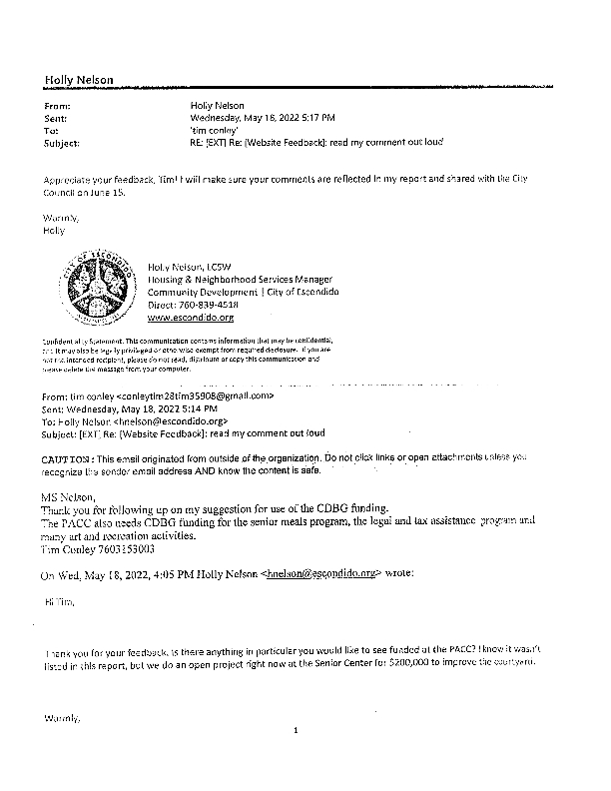
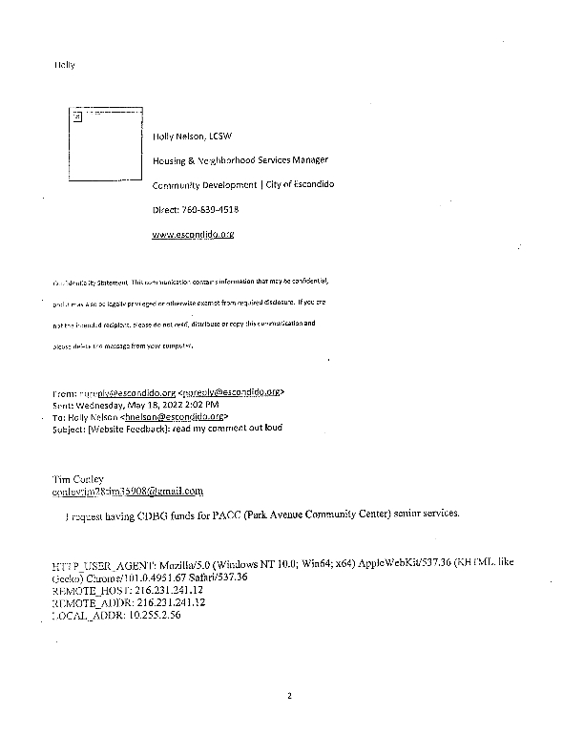
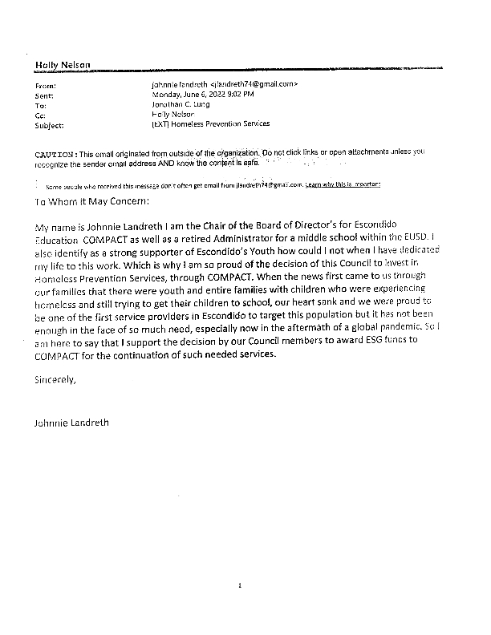
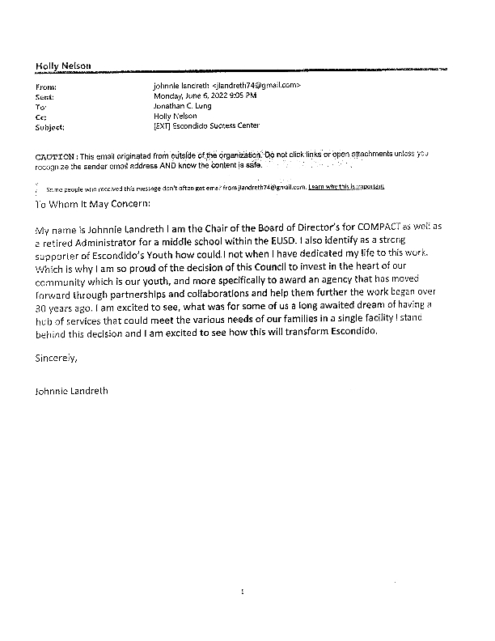
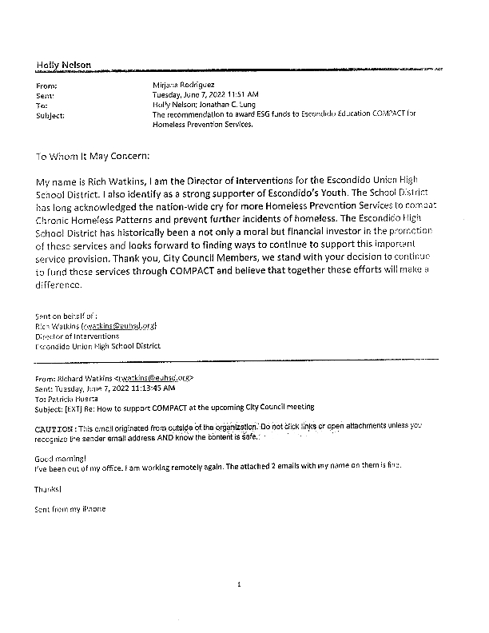
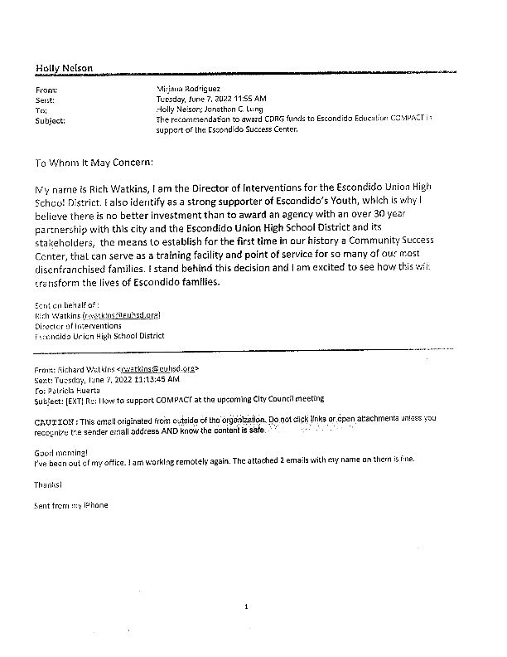
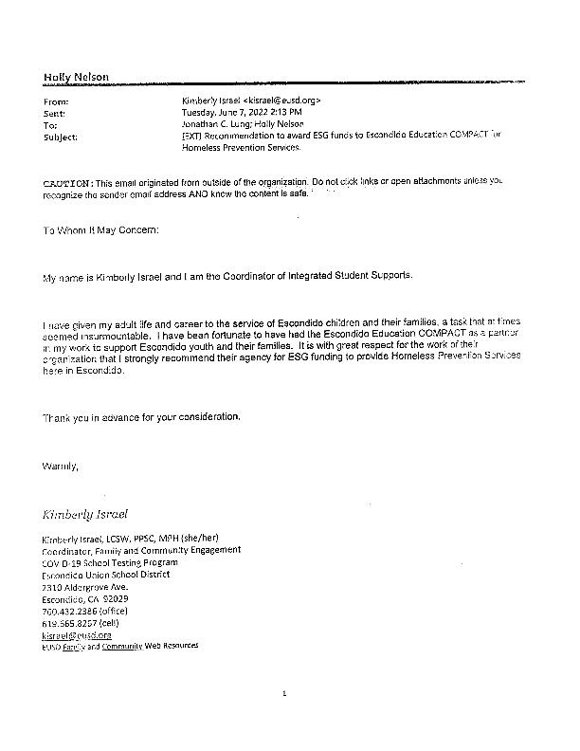
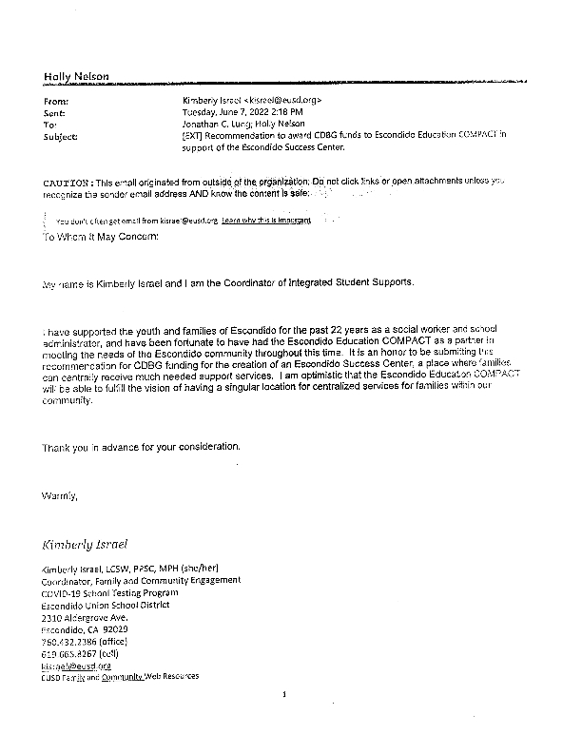
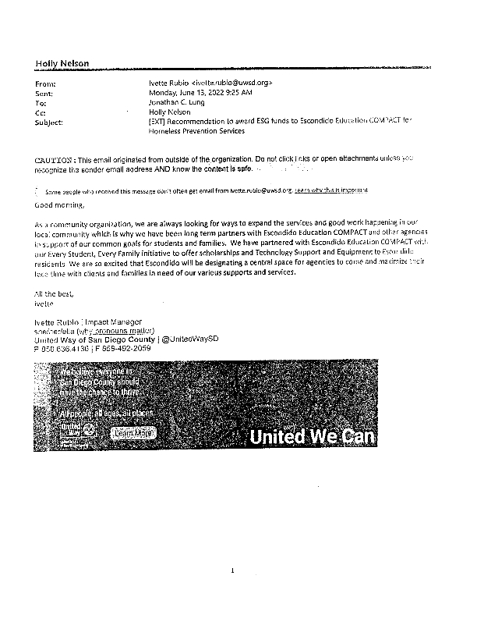
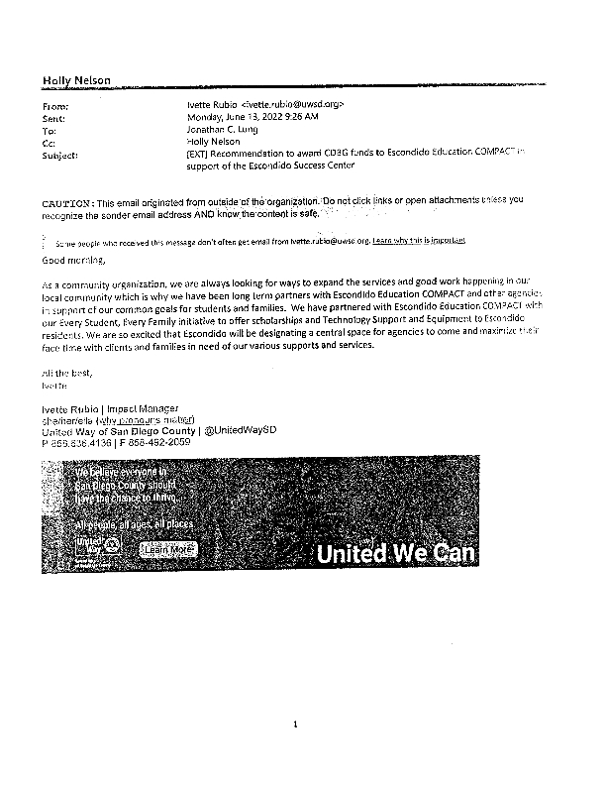
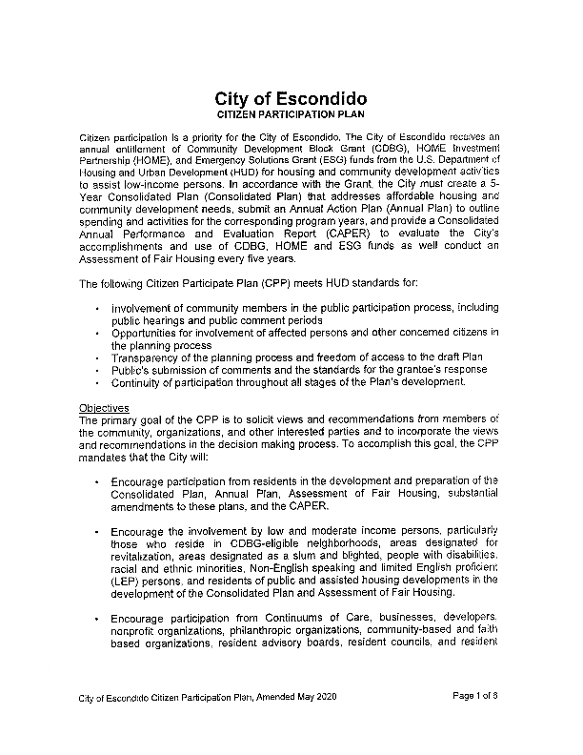
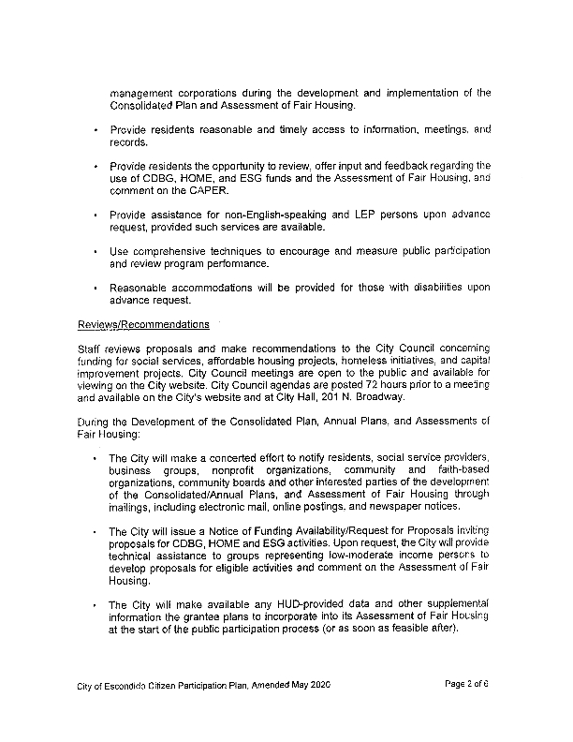
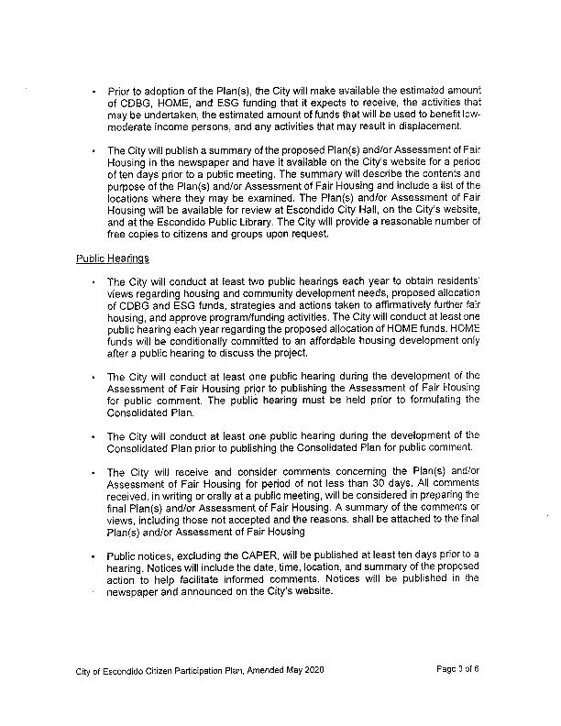
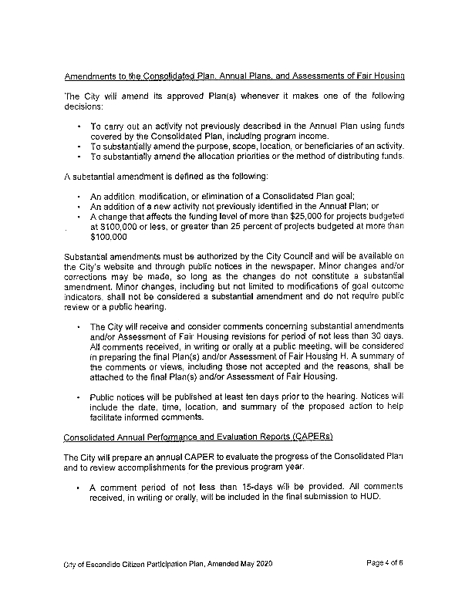
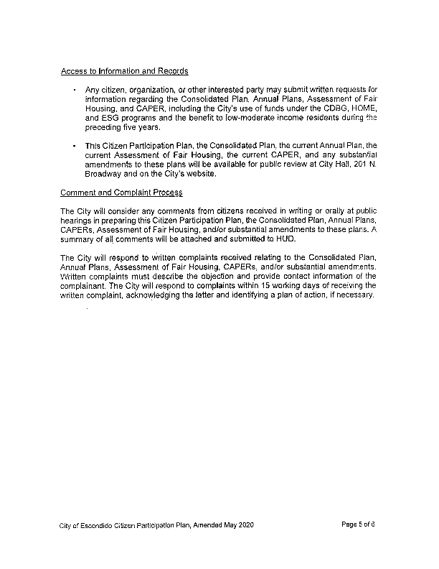
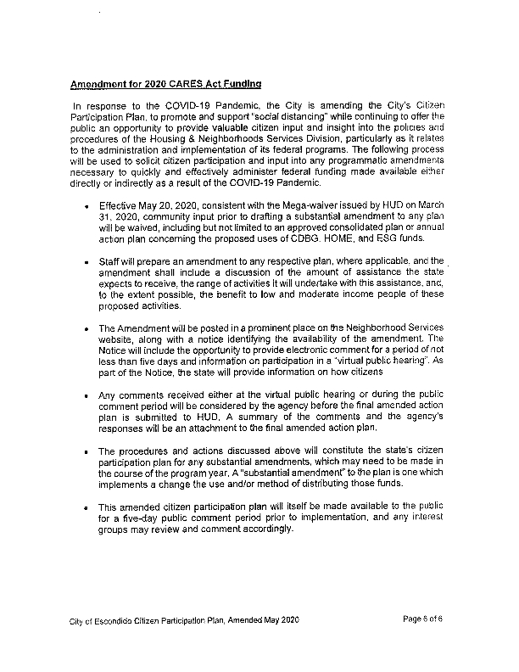

Grantee Unique Appendices
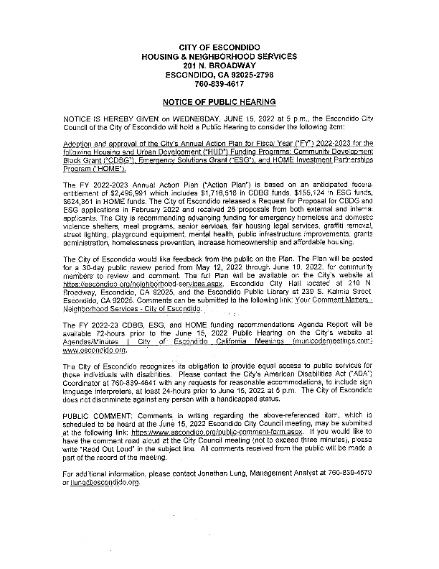
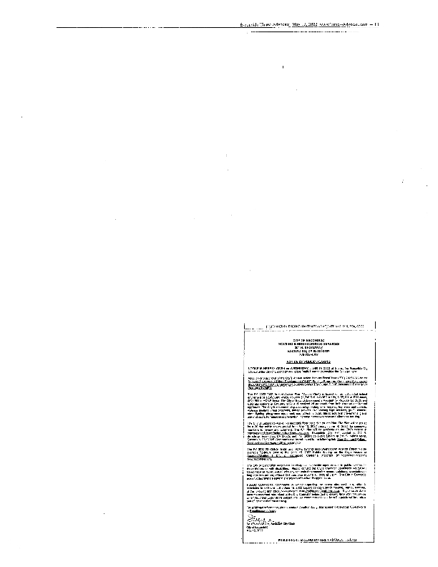

Grantee SF-424's and Certification(s)
